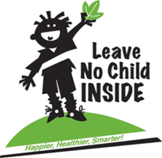**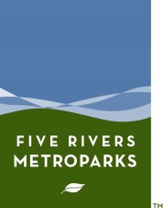4th Annual**

**Miami Valley Leave No Child Inside Summit Agenda**

**February 21, 2015,**

**Wegerzyn Gardens MetroPark**

**Registration required:** <http://www.metroparks.org/GetOutside/SearchByProgram.aspx?program_number=l10>

**Registration begins at 11:00**

**11:30 Welcome** and opening remarks: Today and Tomorrows Doug Horvath

**Noon Keynote Panel Presentation** Including:

**Todd Catchpole**: National Guidelines for Nature Play and Learning Places applied to FRMP

See [www.natureplayandlearning.org](http://www.natureplayandlearning.org)

**Katy Malcolm**: Working with the new Common Core Standards at CWPD

**Amy Dutt**: Urban Wild Ltd - Sustainable Land Design and Central Ohio Natural Playscape Initiative

See [www.facebook.com/pages/Central-Ohio-Natural-Playscape-Initiative/195662613810587](http://www.facebook.com/pages/Central-Ohio-Natural-Playscape-Initiative/195662613810587)

**Robb Clifford** Thoughts on opening a Nature Play Area within Darke County Parks

See [www.countynewsonline.org/events/2014/may/dcparks-play052314.html](http://www.countynewsonline.org/events/2014/may/dcparks-play052314.html)

**Lauren Stayer Asquith** OUTstanding Teacher Award FRMP Presentation

Break

**1:30 MVLNCI Congress** Participants will divide up by interest area:

1. Pre-school and Daycare Teachers and Facilities;

2. Elementary – High School Teachers and Facilities;

3. Parks and Children Service Agencies;

4. Parents, Individual Activists and Churches

A series of resolutions will be offered by each group. Action steps that members are considering will then be recorded. A series of posts on our Facebook page “Get Out in Nature” will allow for each group to continue posting action steps they are taking on these resolutions.

**2:30 Socialize and explore the “Gallery for Children to Connect to Nature.”** At this time, Parents and Children will also be joining us to begin the Discovering Nature’s Alphabet: Nature Clubs for Families program.

**3: 00 MVLNCI Summit Attendees Join in with Nature Clubs for Families and go outside.** Each group will have an assigned guide while they are “Discovering Nature’s Alphabet” in the nearby habitats and gardens, pick one favorite experience that the group enjoyed and then return. (or at least the guide and summit participants will return).

**4:05 Return to Auditorium.** Hear one shortly phrased fun discovery from each discovery group facilitator.

**4:20 Closing Remarks**

Partial list of MVLNCI Partners. To find out how your school or agency can join, contact dhorvath@metroparks.org

[](http://www.thumbprintendeavors.com/images/thumbprint_logo-lrg.gif)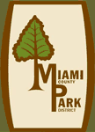[Boonshoft Museum of Discovery](http://boonshoftmuseum.org/)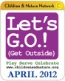Aullwood logo.png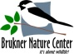\\skydrive\dhorvath\Miami Valley Leave No Child Inside Coalition\partner logos\DCESClogo.jpg